

**LAB REPORT # 03**

**Data Structure and Object Oriented Programming**

**Name: M. Faisal Anwar Khan**

**Reg. Number: 325252**

**Degree: MTS-41**

**Syn: A**

**Date: 17/11/2020**

**Instructor: Ma’am Arshia Arif**

***LAB REPORT # 03***

***Differences between Vectors and Arrays:***

***1 Initialization:***

Arrays are initialized as



Vectors are initialized as



***2 Indexing:***

* Vector is a sequential container to store elements and not index based.

In vectors we can enter value from start one by one till end or we can enter values from end till start one by one. We cannot enter value randomly in between the values. 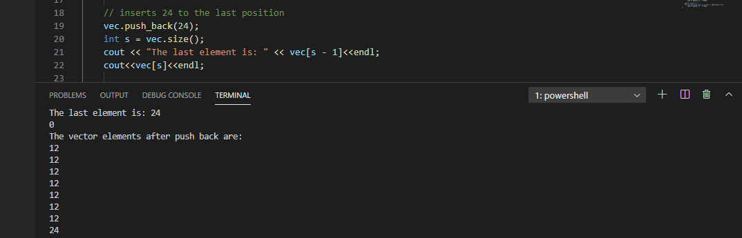

Like in above code , we can see that by using push_back command we enter values from end one by one until we reach start . if we want to enter a single value in any special single declared places then we can’t enter directly.

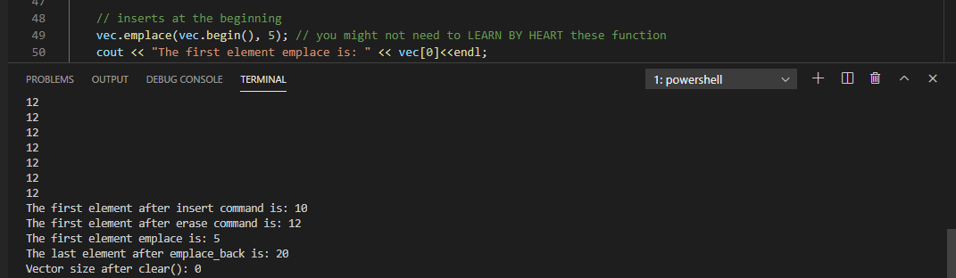

Similarly using vec.emplace function we can enter values both from front and back but we should mention that. In spite of that we cannot enter value in between anywhere.

***In contrast Array,***

Array has capability that we can enter elements in array based on index number,

We can change a particular index element or we can enter a specific number on specific index number.

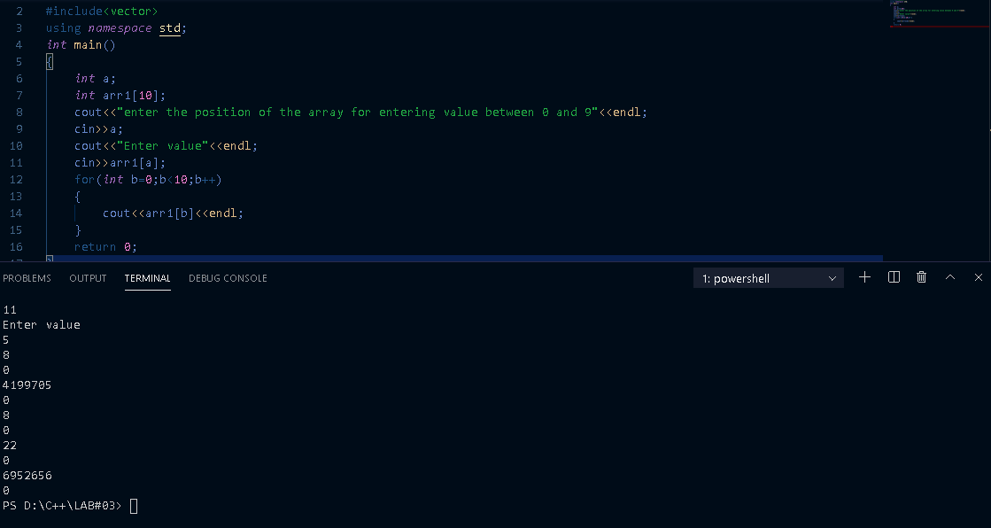

***3 Length:***

In vector we can change size of array at any time .if initially our size is 7 and we want to enter number on place that requires 8 place so vector increase size and allow us to enter value there. It has dynamic memory .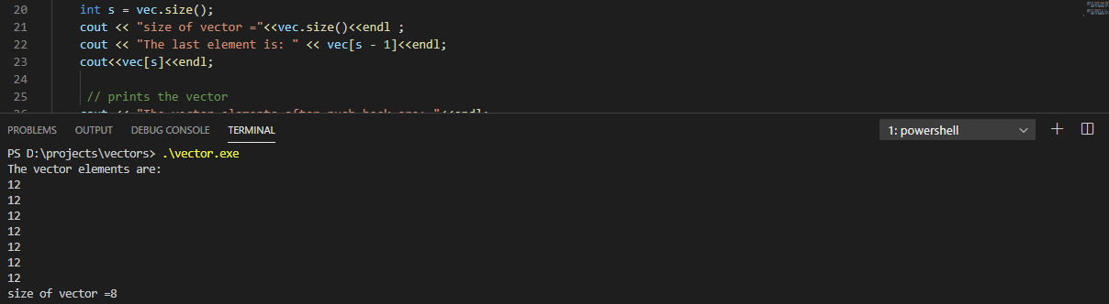

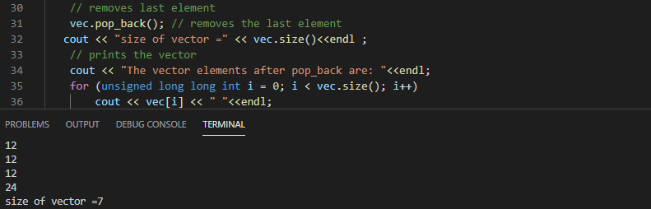

***While in Array,***

Array has fixed size once initialized in beginning of program, it can’t be changed anywhere else in program called as static memory allocation.

***4 Time***

In Vectors Accessing elements is time consuming.

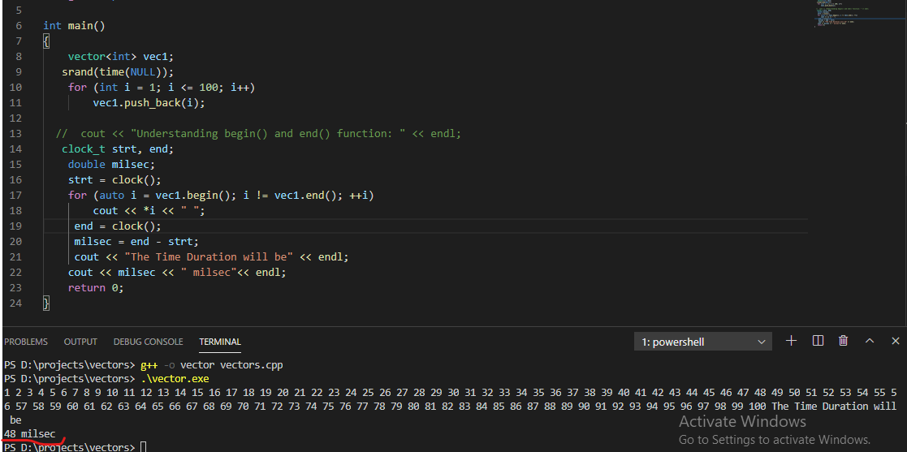

While Arrays are not time consuming .They take less time to access any element.

